1. To implement Insertion and Selection Sort
2. Implementation of Insertion Sort

#include<stdio.h>

void inssort(int ar[],int n)

{

int i,j;

for(i=1;i<=n;i++)

{

int temp=ar[i];

j=i-1;

while(temp<ar[j])

{

ar[j+1]=ar[j];

j--;

}

ar[j+1]=temp;

}

printf("The elements after sorting is\n\n");

for(i=0;i<n;i++)

printf("%d ",ar[i]);

}

main()

{

int n;

printf("\nEnter the total number of elements to be sorted ");

scanf("%d",&n);

int ar[n];

printf("Enter the elements to be sorted\n");

for(int i=0;i<n;i++)

scanf("%d",&ar[i]);

inssort(ar,n);

}

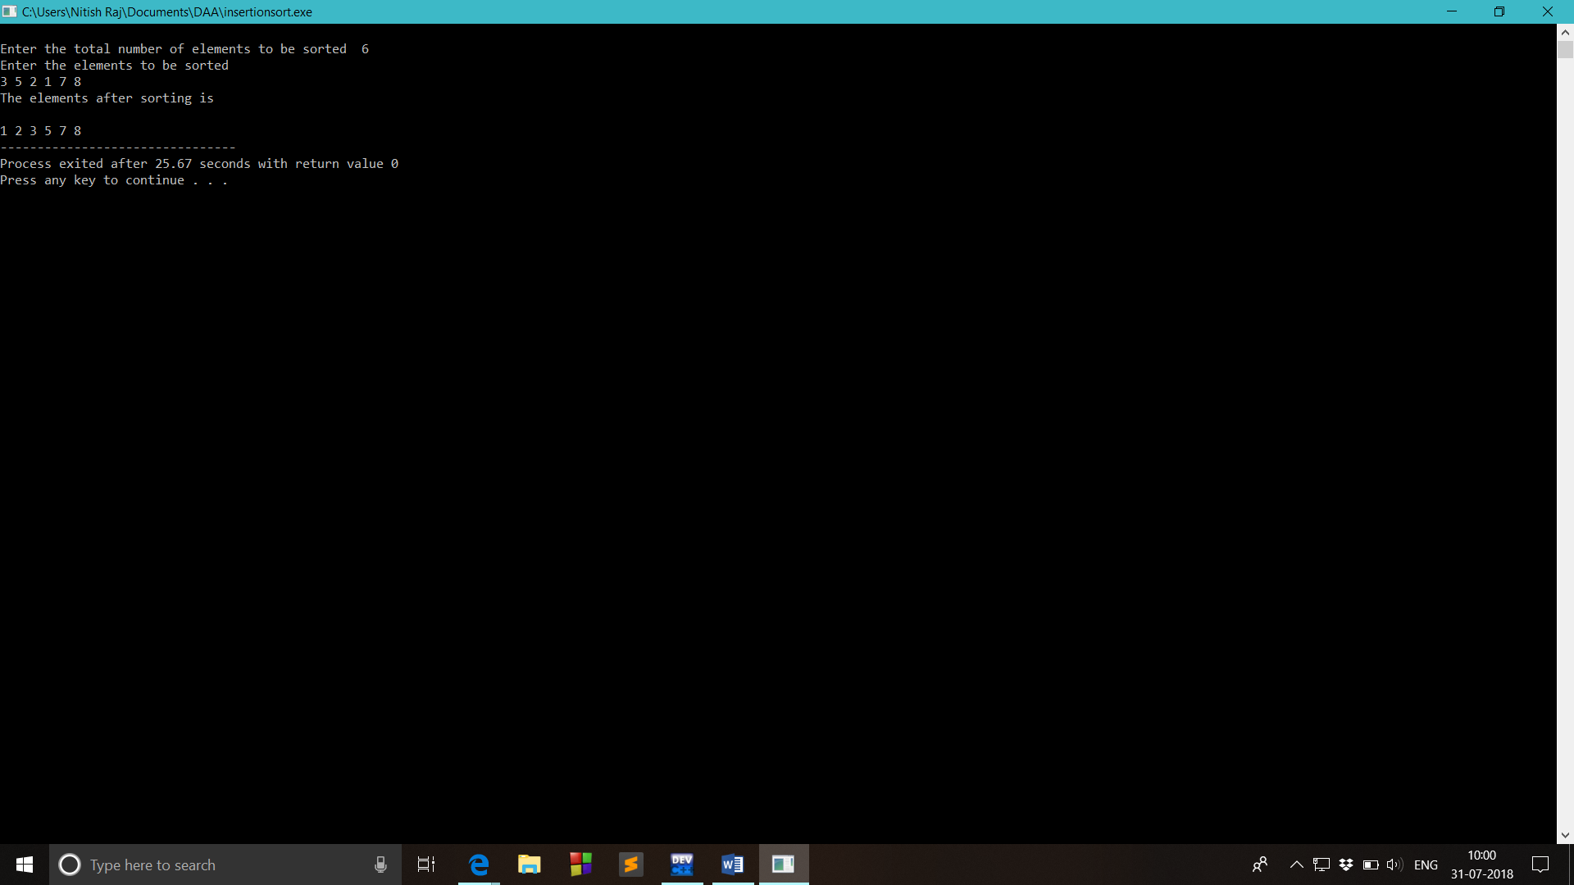

1. Implementation of Selection Sort

#include<stdio.h>

void selection(int ar[],int n)

{

for(int i=0;i<n-1;i++)

{

for(int j=i+1;j<n;j++)

{

if(ar[j]<ar[i])

{

int temp=ar[i];

ar[i]=ar[j];

ar[j]=temp;

}

}

}

printf("\nElements after sorting\n");

for(int i=0;i<n;i++)

printf("%d ",ar[i]);

}

main()

{

int n;

printf("\nEnter the total number of elements to be sorted ");

scanf("%d",&n);

printf("Enter the elements to be sorted\n");

int ar[n];

for(int i=0;i<n;i++)

{

scanf("%d",&ar[i]);

}

selection(ar,n);

}

